A
Project Report On
“Courier Management System”
Submitted in the partial Fulfillment of the Requirements of
BACHELOR OF COMPUTER APPLICATION
Submitted By

Divya Sayajirao Bhadane  PRN: 334411210029 | Vishaka Liladhar Chaudhari  PRN: 334411210027


K.C.E Society’s
Moolji Jaitha College
"An Autonomous College Affiliated to K.B.C. North Maharashtra University, Jalgaon" NAAC Re-Accredited Grade "A" CGPA 3.15 (3rd Cycle)
UGC Honored "College of Excellence"
"Star College" by Ministry of Science and Technology

Academic Year : 2023-24
Guided By
Prof. Pranav Patil

K.C.E. Society’s
MOOLJI JAITHA COLLEGE, JALGAON
"An Autonomous College Affiliated to K.B.C. North Maharashtra University, Jalgaon." NAAC Re-Accredited Grade "A" CGPA 3.15 (3rd Cycle)
UGC Honored "College of Excellence"
"Star College" by Ministry of Science and Technology

Faculty of Commerce

Professional Management

~~~Certificate~~~
This is to certify that Bhadane Divya Sayajirao & Chaudhari Vishaka Liladhar has completed the Project, titled is “Courier Management System” guidance in partial fulfillment of the requirement for the degree of “Bachelor of Computer Application” for the year 2023-2024.

Project Guide HOD

Examiner Examiner

Acknowledgment

The satisfaction that accompanies that the successful completion of any task would be incomplete without the mention of people whose ceaseless cooperation made it possible, whose constant guidance and encouragement crown all efforts with success.
We are grateful to our project guide Prof. Pranav Patil for the guidance, inspiration and constructive suggestions that helpful to us in the preparation of this project.
I acknowledge most sincerely and respectfully CA A. N. Arsiwala, Incharge of Management Faculty, Moolji Jaitha College (Autonomous), Jalgaon.
Finally, I appreciate my colleagues and friends who kindly offered their suggestions, comments and criticism for improvement of this report.

Divya Sayajirao Bhadane  (TYBCA) | Vishaka Liladhar Chaudhari  (TYBCA)

Table of Content

Sr. | Chapter name | Page no.
1. | Introduction | 6
2. | Need | 7
3. | Aim and Objectives | 8
4. | Scope of project | 9
5. | Technology proposed for project | 11
6. | Feasibility Study | 12
7. | Case Tools | 14
8. | Data Flow Diagram | 16
9. | Work Flow | 19
10. | Testing Tools | 20
11. | Project Snapshot | 22
12. | Limitations | 27
13. | Conclusion | 29

14. | References | 30
15. | Undertaking | 31

- Introduction

This Courier Management System Project will have different modules. The login section will have login facility for the admin and for the user who will operate this system. While taking orders from its customers, it will take all the details of its customers who is placing the orders and all the details for the recipient such as its address, name, mobile number. During billing process system will generate a tracking id for their products. Through this tracking id,
customers or its recipient will able to track their products from any location using internet. It will provide status of the product after placing orders within 1 minute.

The courier service is one of the solutions of these problems. It is used to send some things to any person in the world within time. The courier company has number of branches, which are spread over the country or the world. So that when person wants to send things then he has to contact at nearest courier service branch. The courier company creates the schedule & gives internal/external services. The courier service work as destination office or source office.

Need

The implementation of a Courier Management System (CMS) is essential due to:

Efficiency: Automates order processing for swift courier dispatch.
Real-Time Tracking: Provides instant visibility into courier status for customers and staff.
Communication Enhancement: Minimizes misunderstandings with automated notifications.
Data Accuracy: Ensures accurate tracking information and customer details.
Resource Optimization: Optimizes routing and scheduling for efficient resource utilization.
Customer Satisfaction: Improves customer experience with transparent and timely deliveries.
Performance Monitoring: Enables data-driven decisions through reporting and analytics.
Adaptation to Trends: Aligns with industry trends, ensuring competitiveness and relevance.

Aim and Objectives

- Aim:
The aim of the Courier Management System (CMS) project is to develop an efficient and user-friendly platform that automates and enhances the courier management processes, ensuring timely and transparent delivery services.

- Objectives:
- Automation of Order Processing:
Objective: Develop a system that automates the processing of courier orders, reducing manual intervention and improving efficiency.
- Real-Time Tracking and Visibility:
Objective: Implement a robust tracking system to provide real-time visibility into the location and status of couriers for both customers and staff.
- Effective Communication:
Objective: Enhance communication by incorporating automated notifications, ensuring customers and staff receive timely updates on courier status.
- Data Accuracy and Management:
Objective: Establish a centralized database system to ensure accurate and up-to-date tracking information and customer details.

Scope of the Project
- Project Focus:
The Courier Management System (CMS) project aims to optimize and modernize the courier services within the organization, introducing efficiency and transparency.

- Key Aspects:
- Efficient Courier Handling:
- Simplify the booking, tracking, and delivery processes to save time for both staff and customers.
- Ensure a user-friendly interface for submitting and tracking courier requests.
- Streamlined Data Management:
- Develop a centralized database to manage courier-related information accurately and efficiently.
- Automated Communication:
- Implement automated notifications to keep customers and staff updated on the status of their couriers.

- Optimized Resource Allocation:
- Optimize routing and scheduling algorithms for efficient resource allocation, reducing delivery times and costs.

- Project Outcomes:
- Improved Courier Services:
- Enhance communication and transparency between staff and customers.
- Provide real-time updates and tracking for a more responsive courier experience.
- Efficient Data Analysis:
- Develop reporting and analytics tools to monitor courier performance and identify areas for improvement.
- Enhanced Customer Satisfaction:
- Improve the overall customer experience by ensuring timely and transparent courier deliveries.

Technology Proposed for Project

The Courier Management System has been strategically developed using a combination of web technologies to ensure efficiency, user-friendliness, and seamless functionality. The selected technologies include:

- Frontend Development:
- HTML, CSS, JavaScript: These fundamental web technologies are employed to create an intuitive and responsive user interface, ensuring a seamless experience for both students and faculty.
- Backend Development:
- PHP: Leveraging PHP for server-side scripting facilitates dynamic content generation and efficient communication between the frontend and the database.
- Database Management:
- MySQL: The relational database management system MySQL is utilized for its reliability, scalability, and effective handling of structured Courier data.
- Implementation Environment:
- Integrated Development Environment (IDE): Visual Studio Code: Providing a robust and user-friendly IDE for coding, debugging, and version control, ensuring a streamlined development process.

Feasibility Study

At the time of the development, we have gone through the following phases:

1. Economic Feasibility:
- Cost-Benefit Analysis:
Costs: Development, implementation, and training costs.
Benefits: Reduction in manual processing time, improved resource utilization, and enhanced customer satisfaction.
- Return on Investment (ROI):
A detailed ROI analysis indicates the economic viability of implementing the CMS.

2. Technical Feasibility:
- Technology Stack:
Utilizing HTML, CSS, JavaScript for the frontend, PHP for the backend, and MySQL for the database.
- Infrastructure:
Evaluation of existing infrastructure and required upgrades to support the CMS.
- Development Expertise:
Availability of skilled developers proficient in the chosen technologies.

3. Operational Feasibility:
- User Acceptance:
Assessing the willingness of staff and customers to adapt to the new CMS.
- Training Requirements:
Identifying the training needs for staff to effectively use the CMS.
- Integration with Existing Systems:
Ensuring seamless integration with existing operational systems.

4. Legal and Ethical Considerations:
- Compliance:
Ensuring compliance with data protection laws and industry regulations.
- Ethical Considerations:
Addressing ethical concerns related to data privacy and transparency.

5. Scheduling and Timeline:
- Development Timeline:
Creating a realistic timeline for the development, testing, and implementation phases.

Case Tools

Integrated Development Environment (IDE):

For the development and management of this project, an IDE is crucial. The Integrated Development Environment not only provides a consolidated platform for coding but also for debugging, version control, and often, a built-in terminal for immediate execution.

Preferred IDEs:
Visual Studio Code (VSCode): As a free, open-source, and versatile IDE developed by Microsoft, VSCode offers an extensive extension marketplace that allows users to customize and enhance their coding experience. Key features include IntelliSense, linting, debugging, code navigation, and support for various programming languages.

Other Development Software:
- Windows 10 operating system
- MS Office and Google docs for reports or any other documents.
- Lucid-Chart, erdplus for diagrams
- Xampp : XAMPP is a free and open-source cross-platform web server solution stack package developed by Apache Friends, consisting mainly of the Apache HTTP Server, MariaDB database, and interpreters for scripts written in the PHP and Perl programming languages.

By integrating these tools into the development process, the project ensures a comprehensive and efficient workflow, covering coding, database management, documentation, and visual representation of system components.

Entity Relationship Diagram

An Entity–relationship model (ER model) describes the structure of a database with the help of a diagram, which is known as Entity Relationship Diagram (ER Diagram). An ER model is a design or blueprint of a database that can later be implemented as a database. The main components of E-R model are: entity set and relationship set.

What is an Entity Relationship Diagram (ER Diagram)?
An ER diagram shows the relationship among entity sets. An entity set is a group of similar entities and these entities can have attributes. In terms of DBMS, an entity is a table or attribute of a table in database, so by showing relationship among tables and their attributes, ER diagram shows the complete logical structure of a database.
Rectangle: Represents Entity sets.
Ellipses: Attributes
Diamonds: Relationship Set
Lines: They link attributes to Entity Sets and Entity sets to Relationship Set
Double Ellipses: Multivalued Attributes
Dashed Ellipses: Derived Attributes
Double Rectangles: Weak Entity Sets
Double Lines: Total participation of an entity in a relationship set

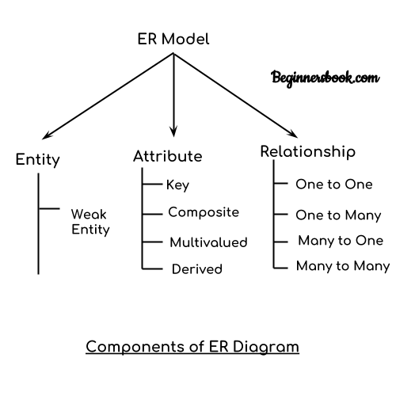

(ER Diagram)

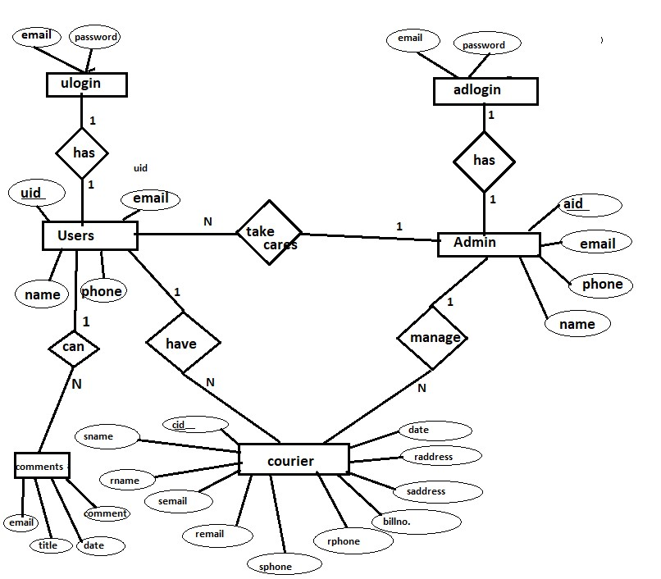

Figure 1: ER Diagram

Work Flow

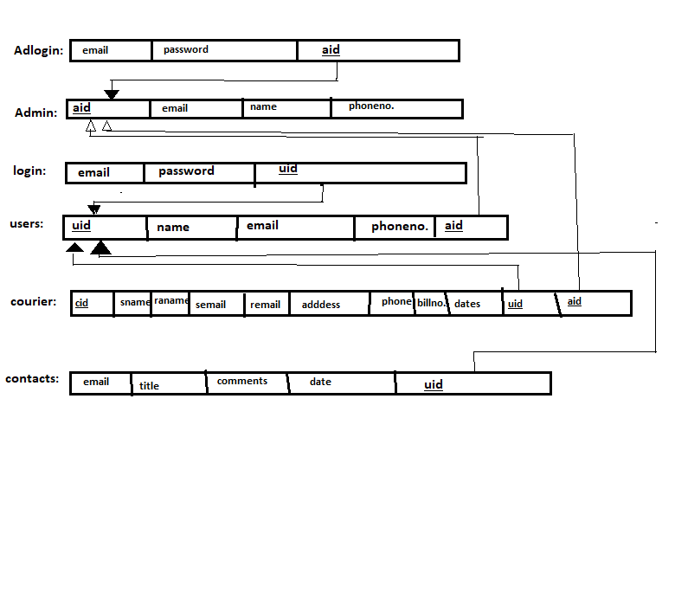

Figure 2:ER Schema Diagram

10.Testing Tools

- Unit Testing:
- Tool: PHPUnit
- Description: PHPUnit is a PHP testing framework. It helps ensure individual components or functions in the code work correctly.
- Integration Testing:
- Tool: Selenium
- Description: Selenium automates web browsers, aiding in testing how different parts of the Courier Management System work together.
- Security Testing:
- Tool: OWASP ZAP
- Description: OWASP ZAP finds vulnerabilities in web applications, making sure the Courier Management System is secure.
- Performance Testing:
- Tool: Apache JMeter
- Description: Apache JMeter simulates multiple users to assess how well the Courier Management System handles heavy usage.
- Load Testing:
- Tool: Loader.io
- Description: Loader.io tests the system's performance under a high load, checking its responsiveness.
- Database Testing:
- Tool: dbForge Studio
- Description: dbForge Studio tests the integrity of the database in the Courier Management System.
- Code Quality and Coverage:
- Tool: Codeception
- Description: Codeception ensures code quality and generates code coverage reports.
- Browser Compatibility Testing:
- Tool: BrowserStack
- Description: BrowserStack tests the Courier Management System on various browsers and devices to ensure compatibility.

11.Project Snapshot

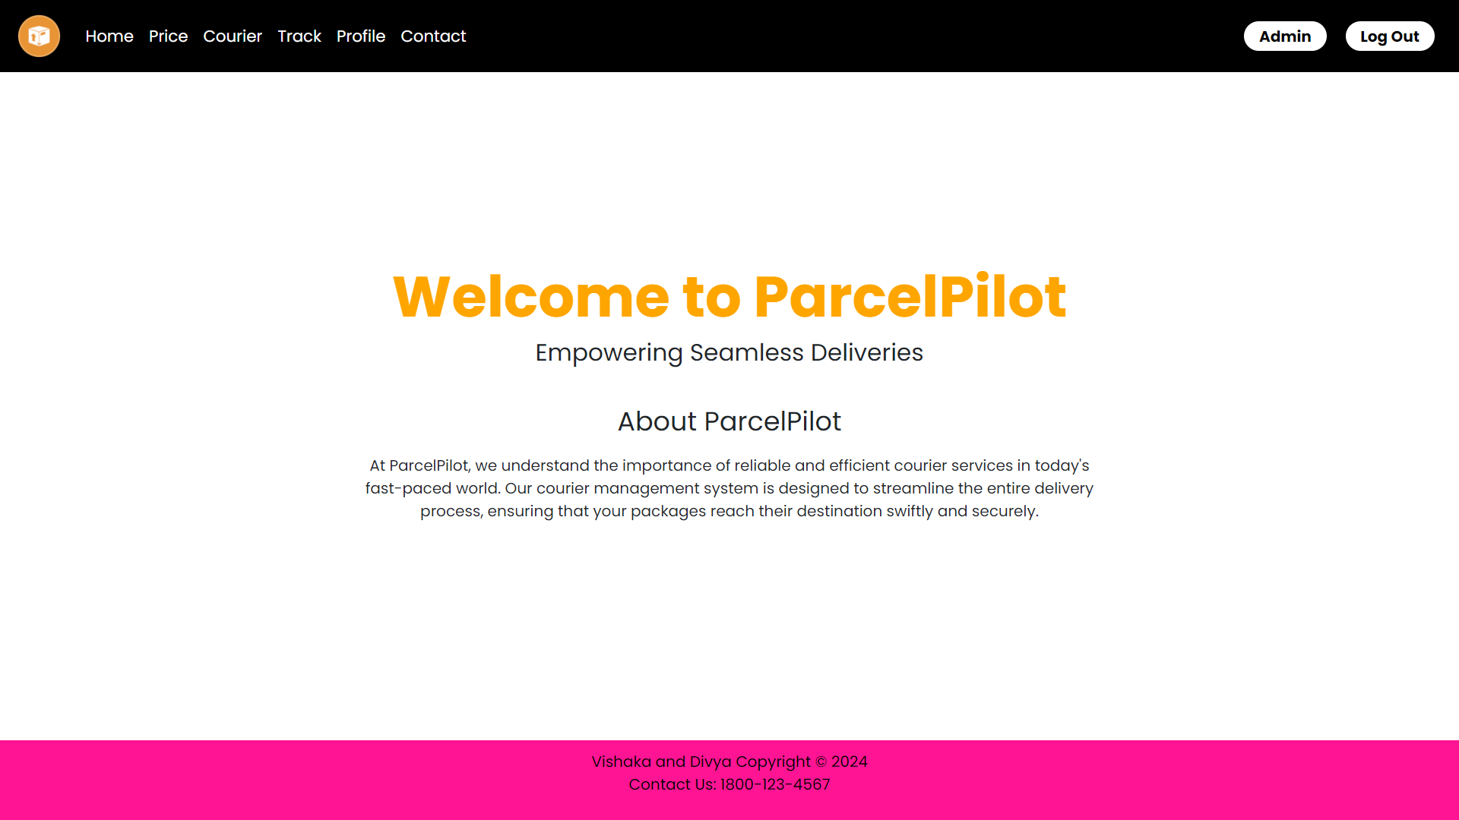

Figure 1: Snapshot 1 (User Home Page)

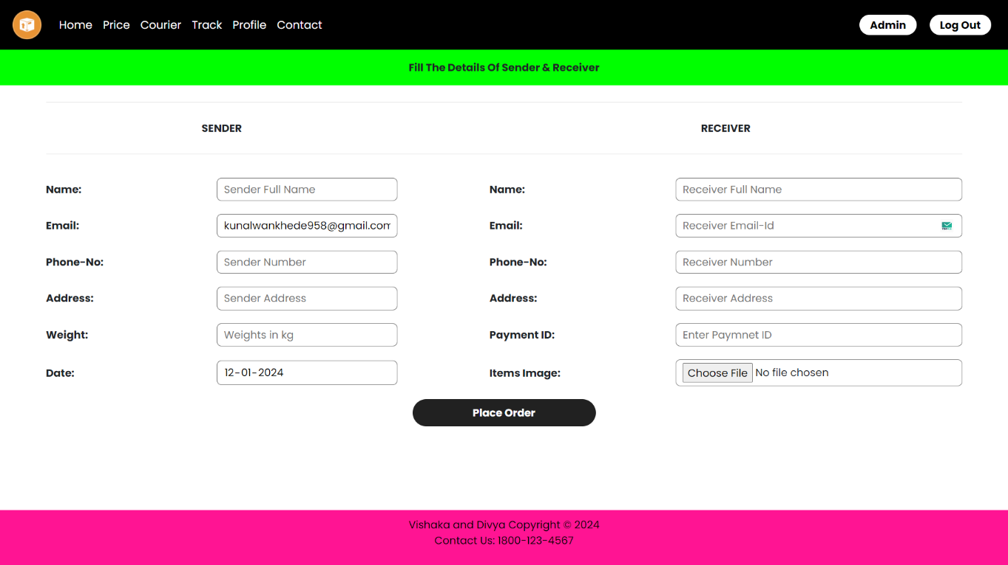

Figure 2: Snapshot 2 (User Courier Page)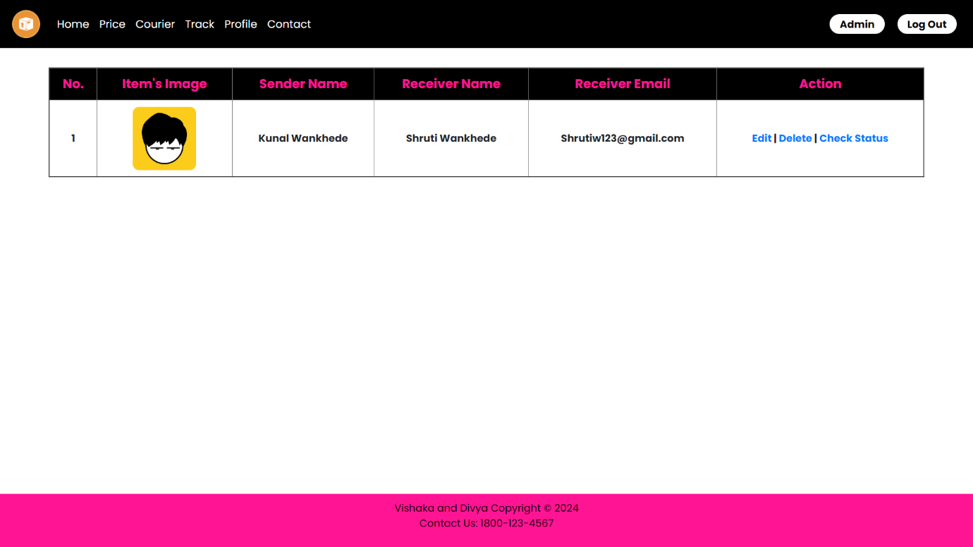

Figure 3: Snapshot 3 (User Track Page)

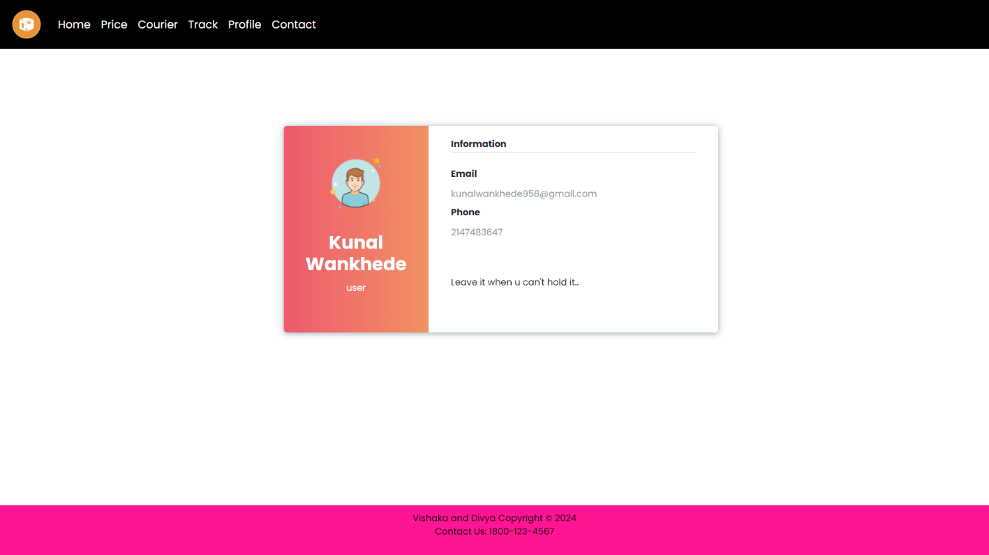

Figure 4: Snapshot 4 (User Profile Page)

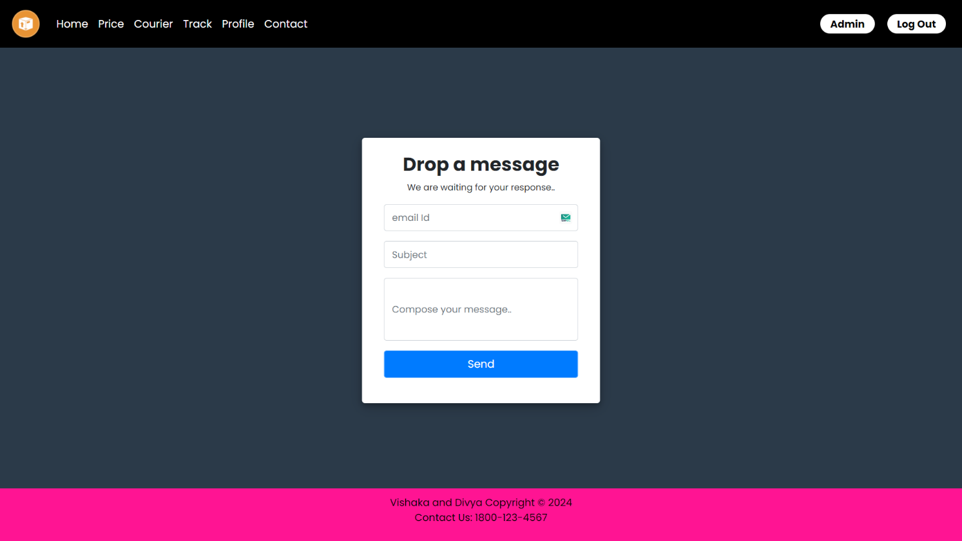

Figure 5: Snapshot 5 (User Contact Page)

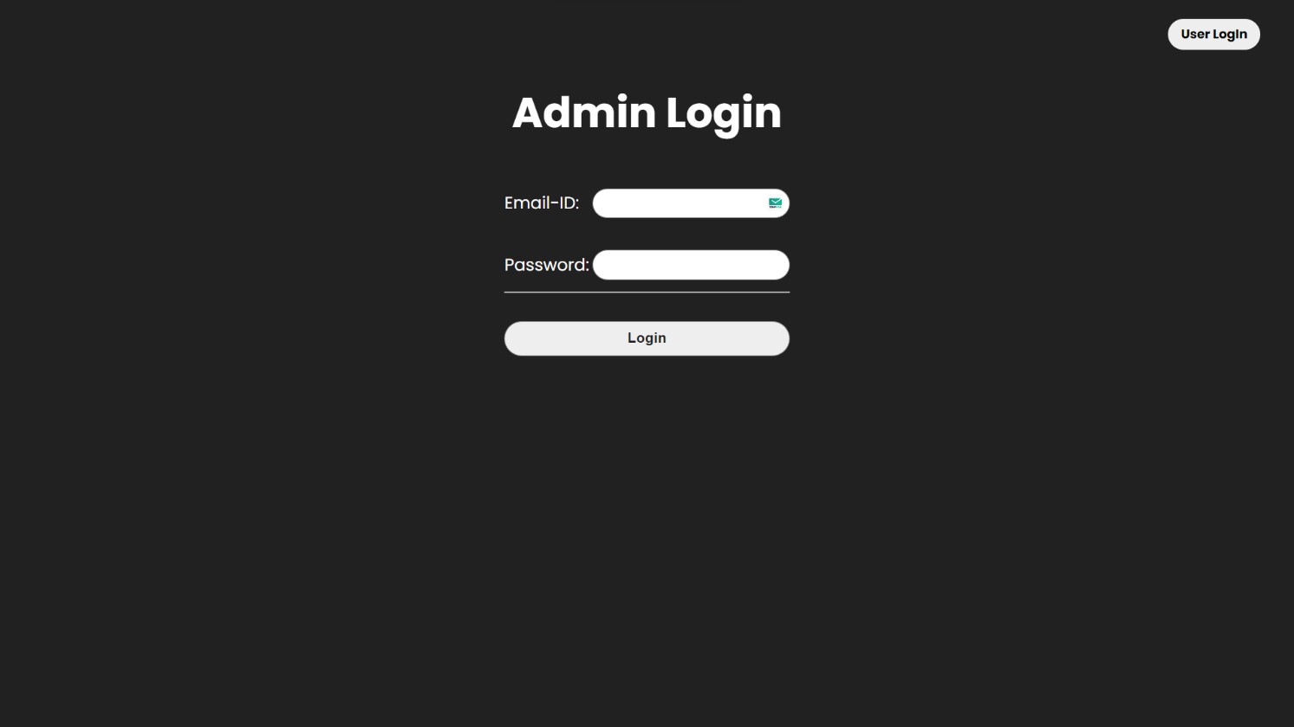

Figure 6: Snapshot 6 (Admin Log-In Page)

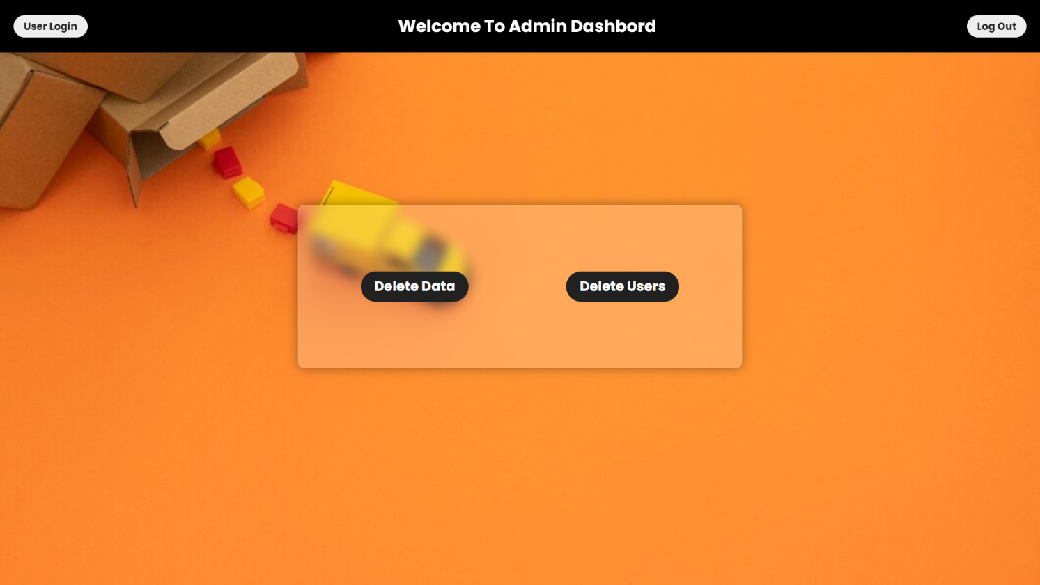

Figure 6: Snapshot 6 (Admin Dashboard Page)

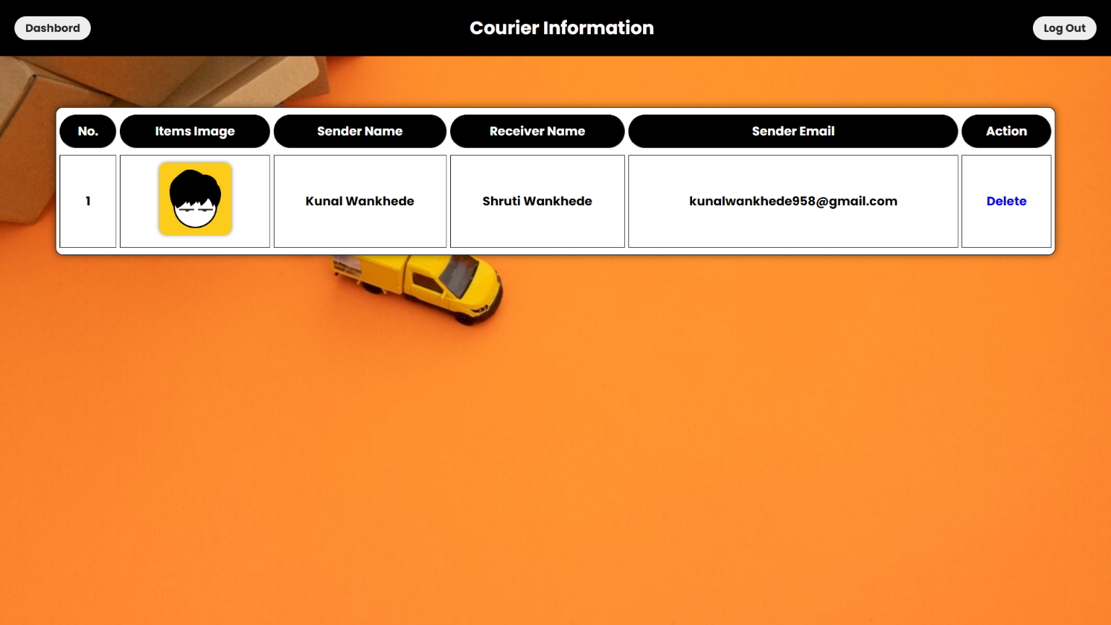

Figure 7: Snapshot 7 (Admin Courier Info Page)

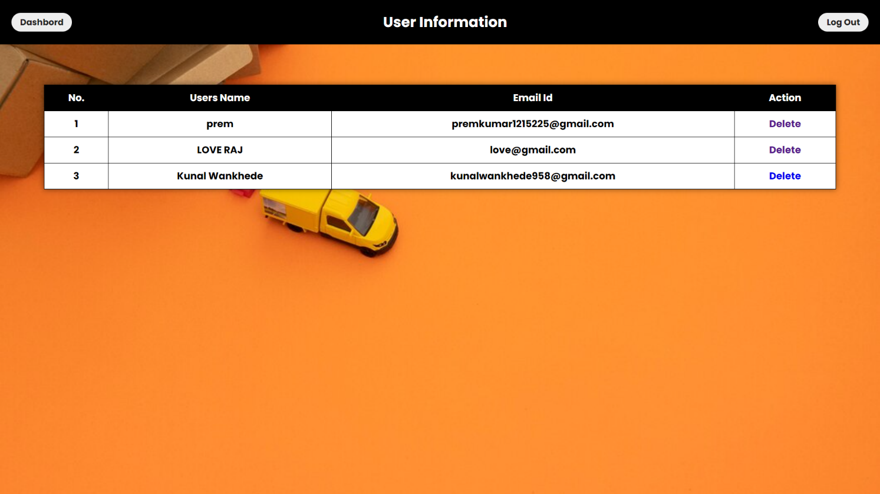

Figure 8: Snapshot 8 (Admin User Info Page)

12.Limitations

While the Courier Management System (CMS) aims to enhance and streamline courier services, it is essential to acknowledge potential limitations and challenges that may arise during its implementation and operation:
- Internet Dependency:
- Issue: The CMS relies on a stable internet connection for real-time tracking and communication.
- Mitigation: Develop offline functionalities for critical processes and ensure redundancy for internet-dependent features.
- Initial Implementation Costs:
- Issue: The upfront costs associated with system development, training, and infrastructure upgrades.
- Mitigation: Conduct a thorough cost-benefit analysis and explore phased implementation to manage initial expenses.
- Resistance to Change:
- Issue: Staff and customers may resist adapting to new processes and technologies.
- Mitigation: Implement a comprehensive training program, address concerns, and communicate the benefits of the CMS.
- Data Security Concerns:
- Issue: Potential risks related to data breaches and unauthorized access to sensitive courier information.
- Mitigation: Implement robust encryption protocols, access controls, and regular security audits to safeguard data.
- Integration Challenges:
- Issue: Challenges in seamlessly integrating the CMS with existing operational systems.
- Mitigation: Conduct thorough compatibility testing, and collaborate closely with IT teams to address integration issues.

13.Conclusion

The Courier Management System (CMS) project has reached its successful completion, introducing a modern and efficient solution for managing courier services within the organization. The system is designed to optimize processes, enhance transparency, and elevate customer satisfaction.

Implemented using HTML, CSS, JavaScript, PHP, and MySQL, the CMS provides a user-friendly interface for staff and customers alike. The utilization of these technologies ensures a robust and responsive courier management platform.

While the current version of the CMS focuses on core functionalities such as booking, tracking, and communication, future enhancements may include the integration of advanced technologies and features to further improve efficiency and competitiveness. These potential additions could involve real-time route optimization, AI-driven analytics, and expanded customer engagement tools.

The commitment to ongoing improvement and adaptation to industry trends will be crucial for maintaining the system's effectiveness in the dynamic landscape of courier management.

14.References

Books:
- Tanenbaum, A. S., & Bos, H. (2014). "Modern Operating Systems" (4th ed.). Pearson. ISBN: 978-0133591620.
- McFarland, D. (2011). "JavaScript & jQuery: The Missing Manual" (2nd ed.). O'Reilly Media. ISBN: 978-1449399023.
- Ullman, L. (2017). "PHP and MySQL for Dynamic Web Sites" (5th ed.). Peachpit Press. ISBN: 978-0134291253.
Websites:
- W3Schools
- Mozilla Developer Network (MDN)
- Stack Overflow
- PHP Documentation
- MySQL Documentation
Online Platforms:
- GitHub
- Tutorialspoint
- GeeksforGeeks
Additional Resources:
- Courier Industry Trends Report 2023
- MySQL Community Edition
- JavaScript MDN Web Docs

15. Undertaking

I hereby declared that the project entitled “Courier Management System” completed and written by me under the supervision of Prof. Pranav Patil, in the partial fulfillment of the requirement for the award of degree “Bachelor of Computer Application” from Moolji Jaitha College (Autonomous), Jalgaon.
The present work is original and performed by me and previously not formed the basis for the award of any degree or diploma or other similar titles of this or any other University or examining body.

Divya Sayajirao Bhadane  (TYBCA) | Vishaka Liladhar Chaudhari  (TYBCA)

